Goal of the Exercise
The goal of this exercise is to test your understanding of a Cloud Compute deployment with Terraform.
You are tasked with creating a codebase for a microservice deployment on a cloud environment, using Terraform. Since our focus is not the application itself, the service will be a simple web server that returns a static page.Requirements
Service Details
- The service will be a simple web server that returns a static page.
- You can use apache2 or nginx to serve a simple HTML file.
- The service should be containerized and stored in a Docker registry.
- The service should be deployed on a single VM instance as a docker container.
- The image should be pulled from the registry specified earlier.
- The service should not be accessible from the internet but only through a Load Balancer, except for SSH access from specific IP addresses.
Deliverables
You are to provide the following as part of your solution:
- Dockerfile to build the image.
- Terraform codebase to deploy the following:
  - Docker registry
  - VPC and all required networking resources
  - EC2 instance
  - Load Balancer
Notes
- Since a CI/CD pipeline is not part of this exercise, we will work around that with the help of Terraform.
- To push the image to the Docker registry, build the image locally before running the Terraform code.
- Once the image registry is created, use Terraform to push the local image to the registry.
- Similarly, use Terraform to pull the image from the registry and run it on the VM instance once it is created.
- For SSH access:
  - Use a locally created key.
  - Add it to the cloud provider key storage.
  - Attach it to the instance.
- Use Terraform best practices for file structure and code organization.
  - Use variables, locals, modules, etc. when appropriate.
- Include all tfvars, scripts, and other helper files used to deploy the application.
- You may use any cloud provider of your choosing, although AWS is preferred.
- Use a free tier account or a trial account to deploy the resources.

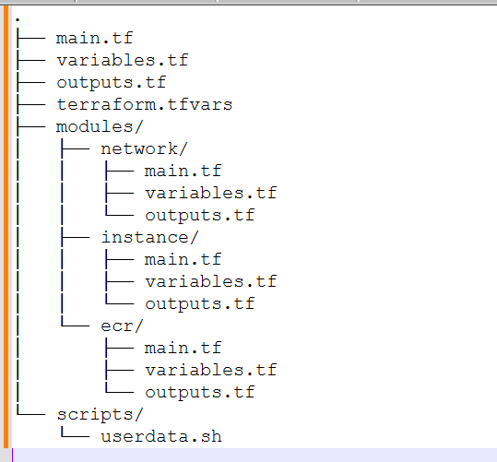
Create this structure and put the files in git hubrepo
https://github.com/sunil-th/terraform-microservice-deployment.git
clone the repo to your local system
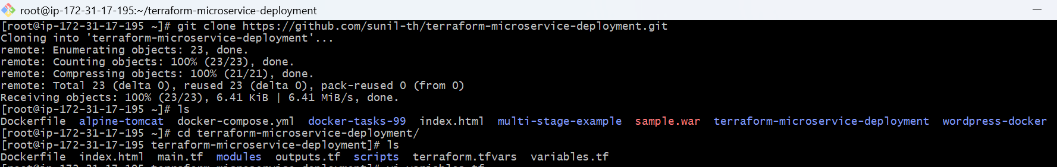

Configure AWS CLI
- Make sure you have your AWS credentials set up locally (aws configure).
  - You’ll need your Access Key, Secret Key, region, and output format.

Install the Terraform
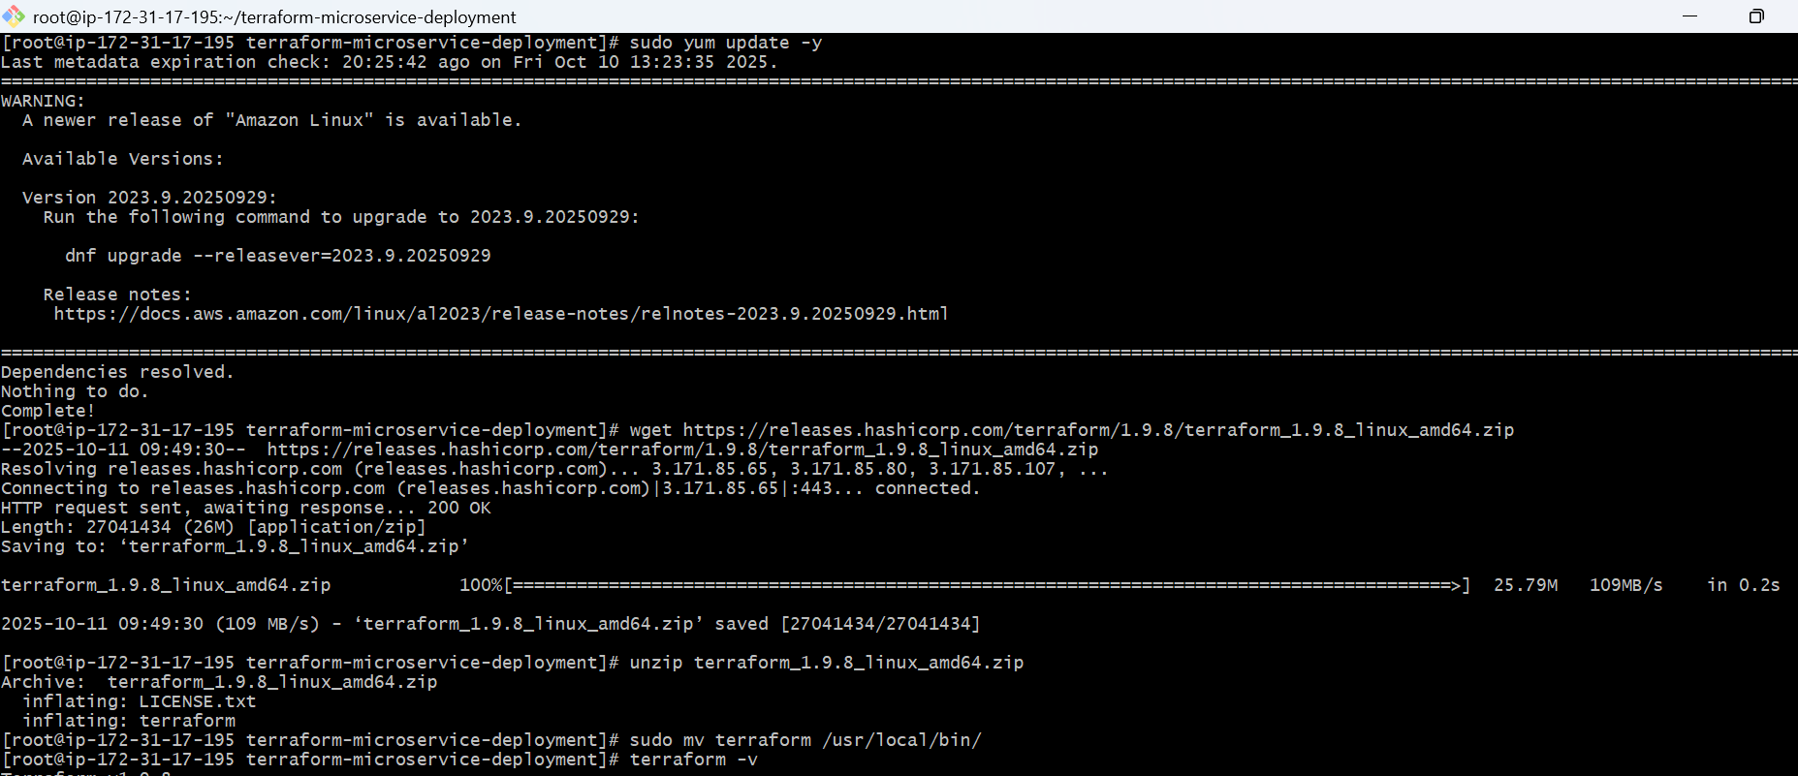
Initialize Terraform
- Run the Terraform initialization command to download required providers and prepare the workspace.
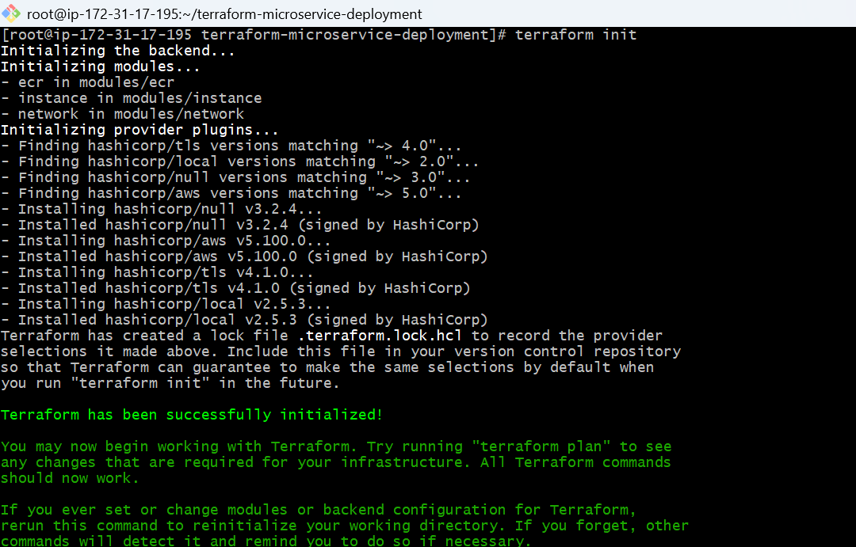

. Review the execution plan
- Generate and review a plan to see what resources Terraform will create.
- This step helps you confirm before applying.

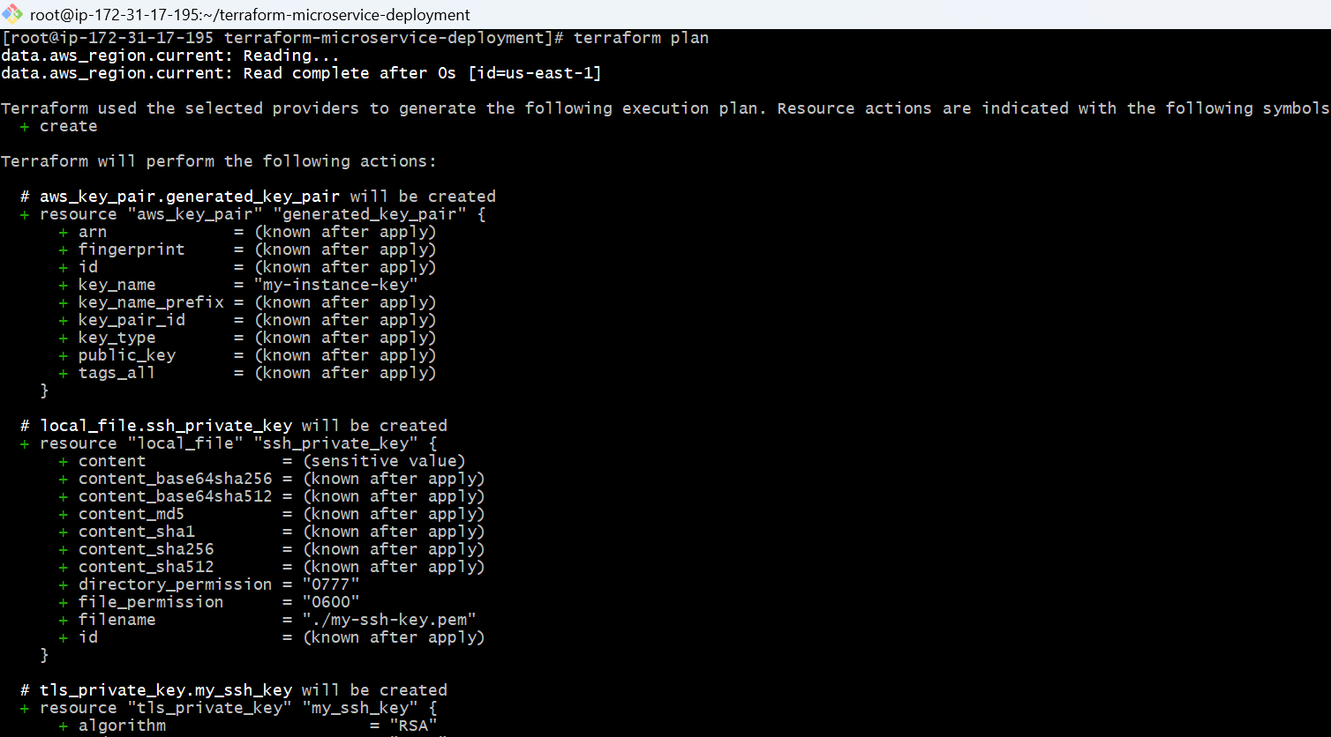

Apply the Terraform plan
- Run the apply command to actually create your AWS infrastructure.
- Terraform will prompt for confirmation — type yes when you’re ready.
- Terraform apply
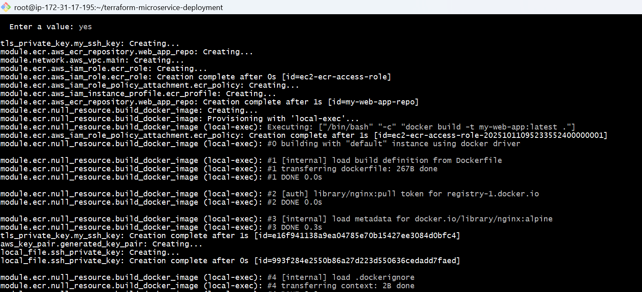
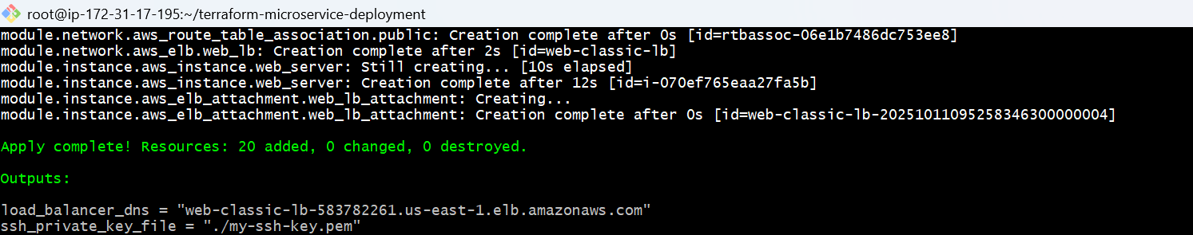

Check docker images
Docker ps
Docker run

Verify deployment
- Use your AWS Console or AWS CLI to verify:
  - The VPC, subnets, ECR repository, and EC2 instance exist.
  - Your container is running on the EC2 instance.
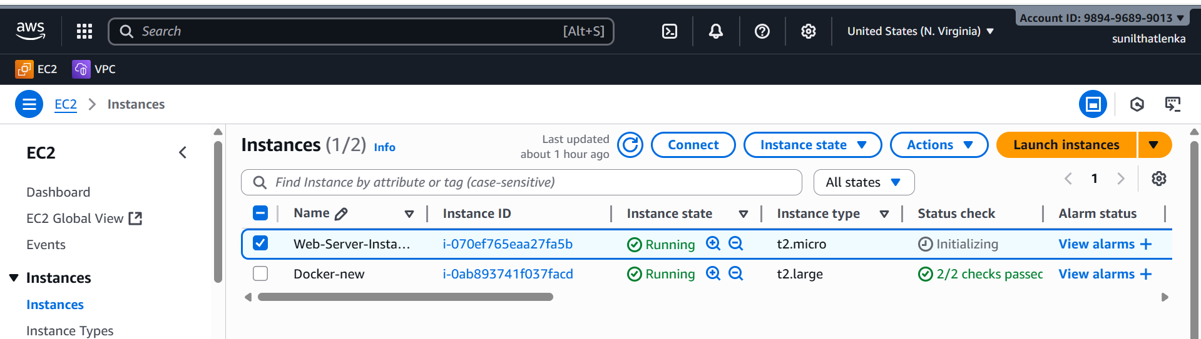

pushes the images to the ECR
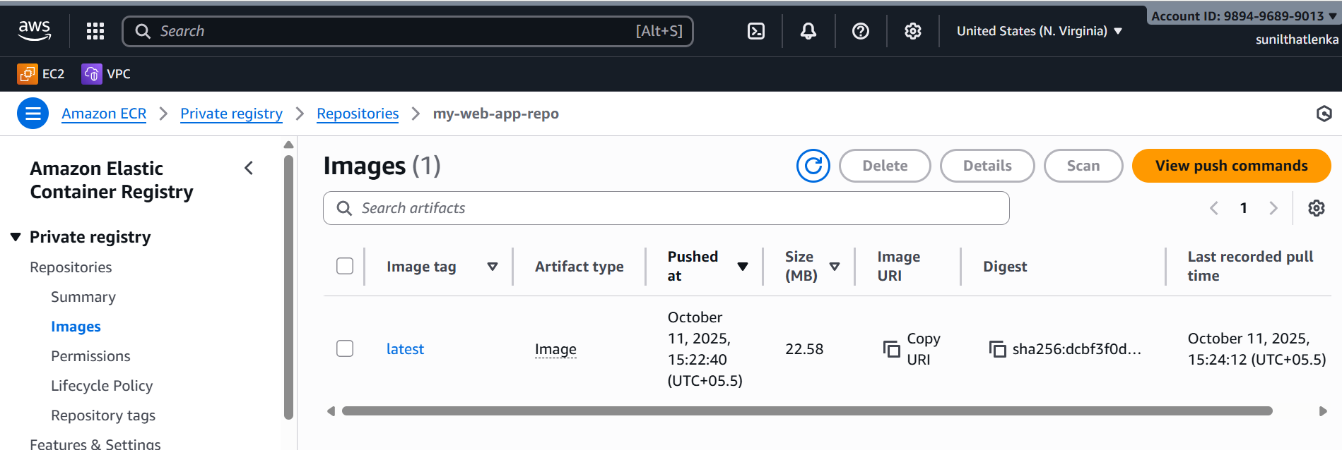
Load Balancers
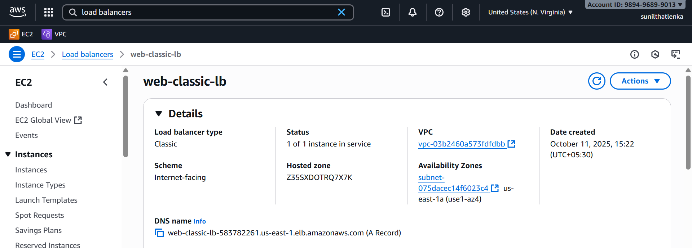
copy the dns link and verify in the web
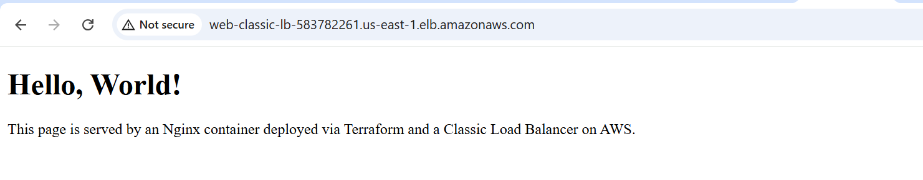

High-Level Architecture
Here’s the overall architecture of what Terraform builds:
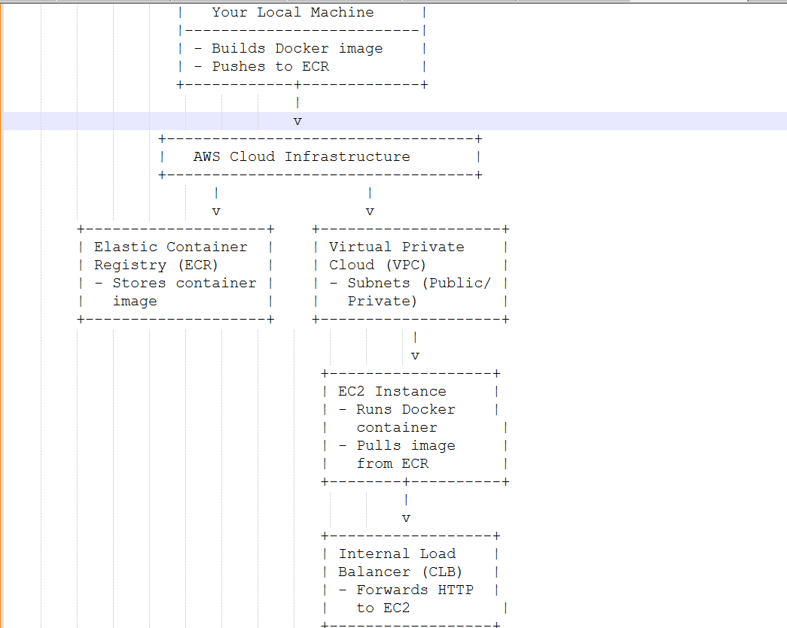

⚙️ Step-by-Step Conceptual Breakdown

1. Docker & Web Service
- You build a simple static web service using nginx or apache2.
- This service serves a basic index.html page.
- You define it in a Dockerfile, which becomes a reusable container image.

2. Docker Registry (ECR)
- You use AWS Elastic Container Registry (ECR) as your private Docker image store.
- Terraform creates the ECR repository.
- You then build and push your Docker image manually (via script) into ECR.
💡 Why?
In a real CI/CD pipeline, an automated process would build and push the image. Here, you simulate that manually.

3. Networking (VPC)
- Terraform creates a VPC (Virtual Private Cloud).
- It includes:
  - One public subnet (for the load balancer).
  - One private subnet (for the EC2 instance running the container).
- This separation ensures your app isn’t directly exposed to the internet.
💡 Why?
It’s a best practice to place backend servers in private subnets and expose only controlled entry points (like ALBs).

4. Security Groups
- EC2 Security Group:
  - Allows SSH only from specific IPs you define.
  - Allows HTTP traffic only from the Load Balancer security group.
- ALB Security Group:
  - Allows HTTP (port 80) from within the VPC only.
💡 Why?
This enforces the requirement that the service can only be accessed through the Load Balancer, not directly from the internet.

5. EC2 Instance
- Terraform provisions an EC2 instance in the private subnet.
- It attaches:
  - An IAM Role that allows it to pull images from ECR.
  - A user data script (user_data.sh.tpl) that:
    - Installs Docker and AWS CLI.
    - Logs in to ECR.
    - Pulls the container image.
    - Runs it on port 80.
💡 Why?
This simulates how instances in production automatically deploy and start containers when they launch.

6. Load Balancer (CLB)
- Terraform creates an classic Load Balancer (internal).
- It:
  - Routes traffic to the EC2 instance on port 80.
  - Is internal, meaning it’s not publicly accessible.
💡 Why?
In production setups, ALBs distribute traffic between multiple instances or services within a VPC.
Here, you simulate that with just one instance.

7. IAM & Key Pair
- You create/import an EC2 key pair for SSH access.
- Terraform uses your local public key to register that key pair in AWS.
- The EC2 instance uses that key for authentication.
💡 Why?
This ensures secure SSH access — only you (and allowed IPs) can connect.

8. Terraform Modules & Structure
- The codebase uses modular Terraform design:
  - Each resource group (VPC, EC2, ALB, ECR) is a module.
  - The root module (main.tf) wires them together.
- This improves reusability and organization.
💡 Why?
In real-world DevOps teams, modular design helps manage complex infrastructure and avoid copy-paste duplication.

9. Variables, Locals, and tfvars
- All configurable options (region, instance type, allowed IPs, etc.) go into variables.
- terraform.tfvars holds your environment-specific values.
💡 Why?
This makes your setup portable and easy to modify for different environments (e.g., dev, staging, prod).

10. Deployment Flow
The full workflow is:
- terraform init — initialize modules and providers.
- terraform apply -target=module.registry — create ECR repo.
- Run ./build-and-push.sh <repo_uri> <tag> — build and push image.
- terraform apply — deploy full stack (VPC, EC2, ALB, etc.).
- Terraform automatically:
  - Pulls image from ECR.
  - Starts container on EC2.
  - Connects EC2 to ALB.

✅ What You’ve Achieved
By completing this project, you’ve:
- Used Terraform to build a full AWS environment (IaC principles).
- Used Docker to containerize an application.
- Deployed a container using EC2 and user-data scripts.
- Secured access via IAM, VPC, and security groups.
- Modularized Terraform code for clarity and reuse.

